Heal Well Website Improvement Project

By: Alex Li, Casey Detwiler, Hanwen Wang, and Krish Nair

Sponsored by Heal-Well

Faculty Advisor: Dr. Sayed Reza

Subject to change

# Introduction

## 1.1 Problem Statement

This project aims to enhance the existing Heal-Well website by collecting diverse user data through initial and periodic review questionnaires. We plan to incentivize user engagement by implementing a reward system and refining the notification system. Additionally, we will update the website to enable the utilization of collected data, either by physicians or through a machine learning algorithm, for the improvement of exercise plans provided to users. The significance of this project lies in its potential to offer users valuable information and exercises, which can contribute to their health both before and after their planned surgery.

# Specific Requirements

## 2.1 Functional Requirements

### 2.1.1 Data Collection Functional Requirements

To effectively evaluate the performance of current video subscriptions, monitoring key metrics associated with user behavior is essential. The existing system passively records only the number of videos completed and the duration of viewership by users. Consequently, there is a need to develop a more comprehensive system. This enhanced system should proactively solicit user feedback through questionnaires and track a broader range of user behaviors.

### 2.1.2 Incentive System Functional Requirements

In order to enhance the engagement of users and foster consistent participation in Heal-Well's online courses, a reward system will be implemented on the website. The primary objective of this feature is to motivate and prompt patients to stay involved with Heal-Well's online courses. Upon successfully completing a challenge, patients will be awarded a virtual badge that they can showcase in their user profile.

### 2.1.3 Existing Issues

To address the concerns present in the current Heal-Well website, we plan to implement corrective measures. Currently, the website does not validate critical user data, including date of birth and weight, among others. Our goal is to introduce robust validation mechanisms to ensure data integrity and quality throughout the data collection process. Furthermore, the website currently lacks input validation, which permits users to enter unrealistic numbers for their weight or to input past or excessively distant dates for surgery.

### 2.1.4 Improved plan recommendation

Currently, the Heal-Well website provides the same health training videos for all patients regardless of their personal health goal. We aim to introduce a machine learning algorithms to deliver personalized training plans for each patient.

### 2.1.5 Redesign Heal-Well webpage

As of now, the Heal-Well website does not have any registered customer accounts, despite receiving numerous visits. Our objective is to enhance the website design to encourage more sign-ups. We propose incorporating a statement emphasizing Heal-Well as a not-for-profit organization, promoting free sign-up. Additionally, we plan to introduce several videos that provide insights into the content customers can expect upon enrolling in Heal-Well rehabilitation.

## 2.2 Intended Technologies

### 2.2.1 React

The current website utilizes the React framework, renowned for its flexibility and scalability. React's component-based architecture allows for efficient development and maintenance, enabling the creation of reusable, independent components that can be seamlessly integrated. This modularity not only streamlines the development process but also enhances the site's adaptability for future enhancements and features. Furthermore, React's strong community support and rich ecosystem of tools and libraries provide a robust foundation for future development and innovation.

### 2.2.2 Next.js

Next.js is utilized as the module management system for backend services. It offers server-side rendering and static site generation for better performance, efficient routing for enhanced user experience, and automatic code splitting for lighter pages. Its built-in API routes facilitate backend integration. We plan to continue using Next.js for its scalability, ease of development, and versatility in this project.

### 2.2.3 Clerk

To simplify user authentication and information management, the current system adopted Clerk as our authentication service. Clerk enhances security with features like two-factor authentication and single sign-on, while its user-friendly interface and robust API ensure seamless integration and efficient user management. This approach significantly improves both user experience and data security.

### 2.2.4 MySQL

Currently, our database uses MySQL, valued for its ease of use and quick development cycle. While MySQL excels in structured data handling and integrity, we plan to transition to a NoSQL database due to its flexibility in managing frequent changes in data structures. NoSQL databases can efficiently handle diverse data types and adapt more easily to evolving data needs, offering a scalable solution for our dynamic requirements.

### 2.2.5 Prisma

Prisma, our current tool for database connectivity, is recognized for its effective query-building and type-safe environment. As we plan to switch databases in the future, adjustments in the connection port may be necessary due to different database protocols. Prisma's versatility in supporting various databases will facilitate this transition, ensuring smooth and efficient database interactions during and after the change.

### 2.2.7 AWS

We currently use Amazon Web Services (AWS) S3 buckets to host our video content, chosen for its scalability, reliability, and security. AWS S3 provides robust data protection and efficient management tools for easy upload and retrieval of videos, ensuring a smooth user experience. Its global network also guarantees fast and reliable access for users worldwide, making it an excellent platform for secure and efficient video storage and distribution. It is intended to continue using this for future development.

### 2.2.8 Typeform

We use Typeform for initial user questioning due to its user-friendly and intuitive design, ideal for non-technical users. It allows easy customization of questions and efficient management of responses. This makes it simpler for our team to update questions and handle user feedback, streamlining data collection and enhancing user engagement without needing advanced technical skills.

# GUI demonstration

### 3.1 Current website design

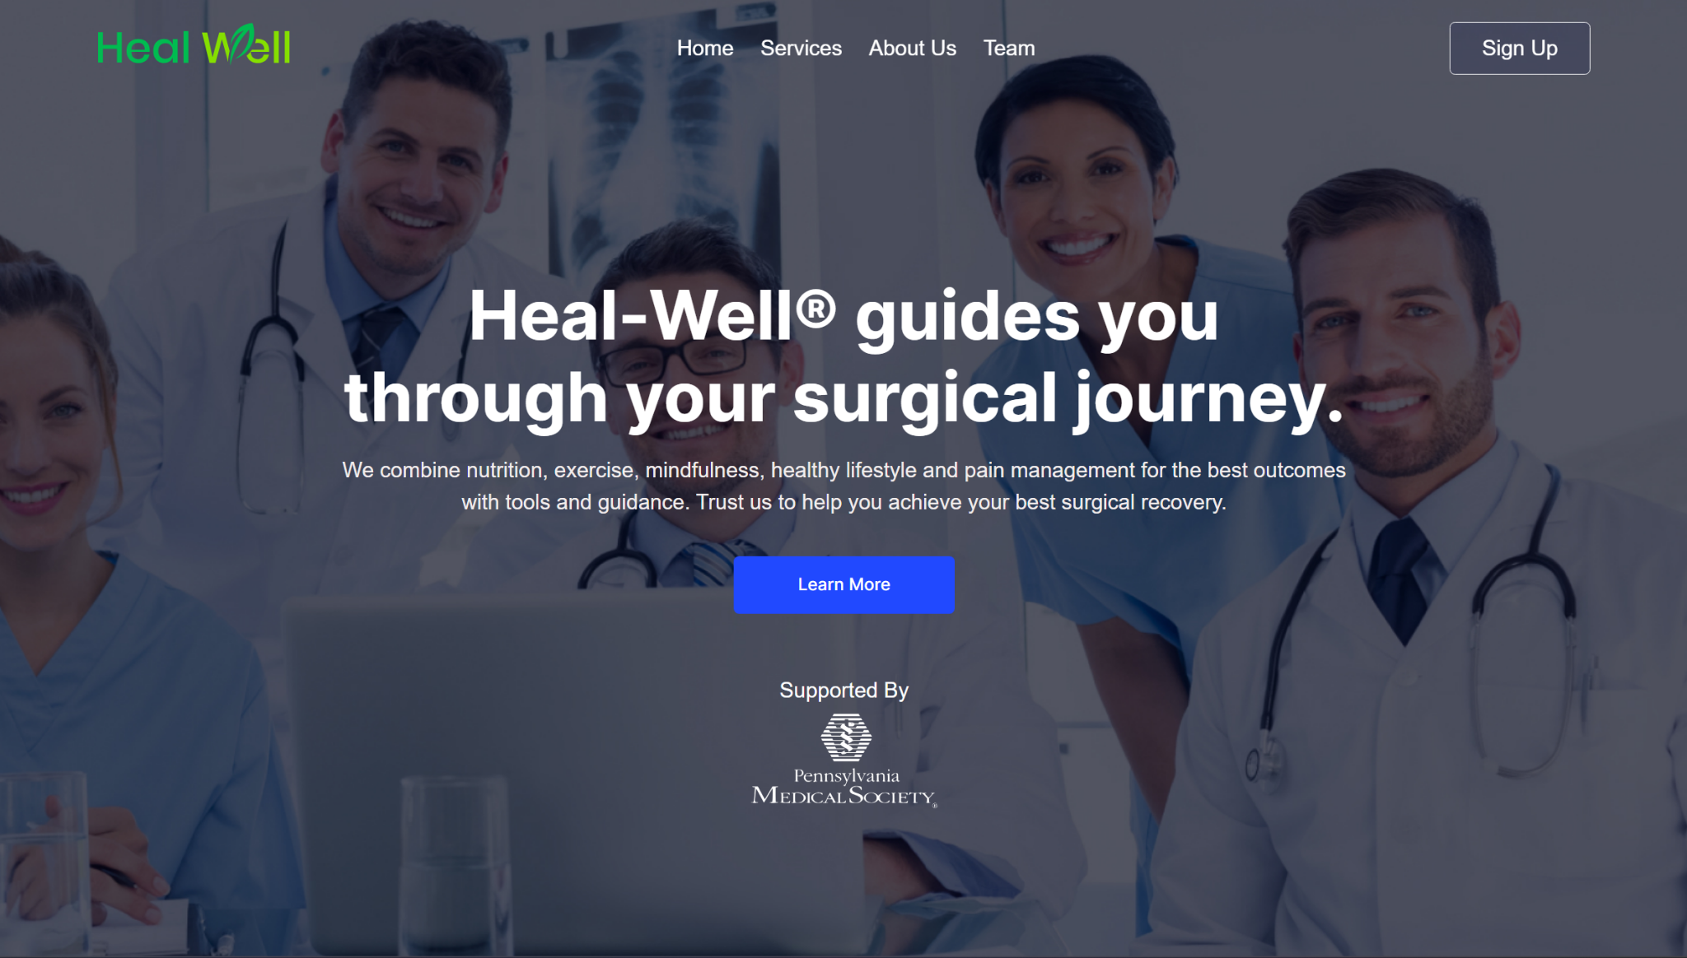

### 3.2 Current Sign up design

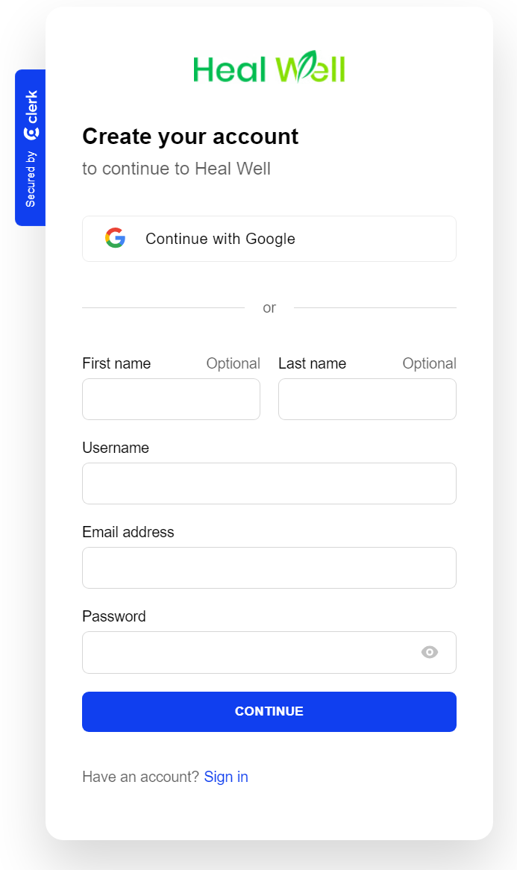

### 3.3 Updated user interface

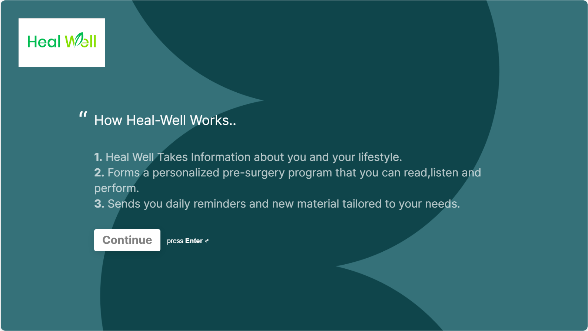

### 3.4 Current user dashboard

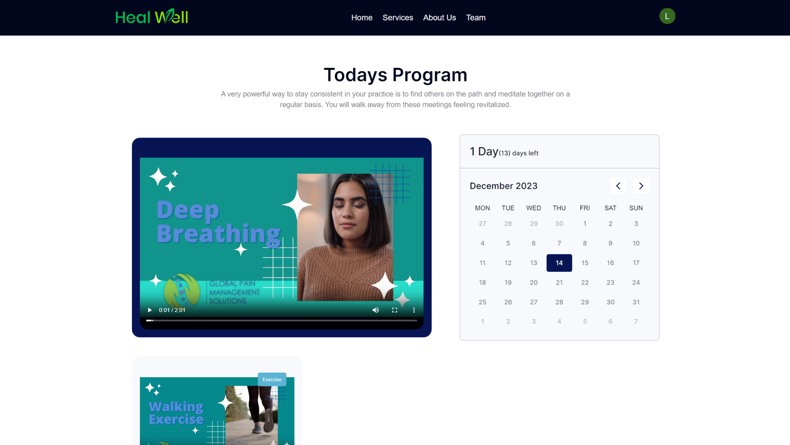

### 3.5 Updated user survey interface

#### Collect responses after the program is completed.

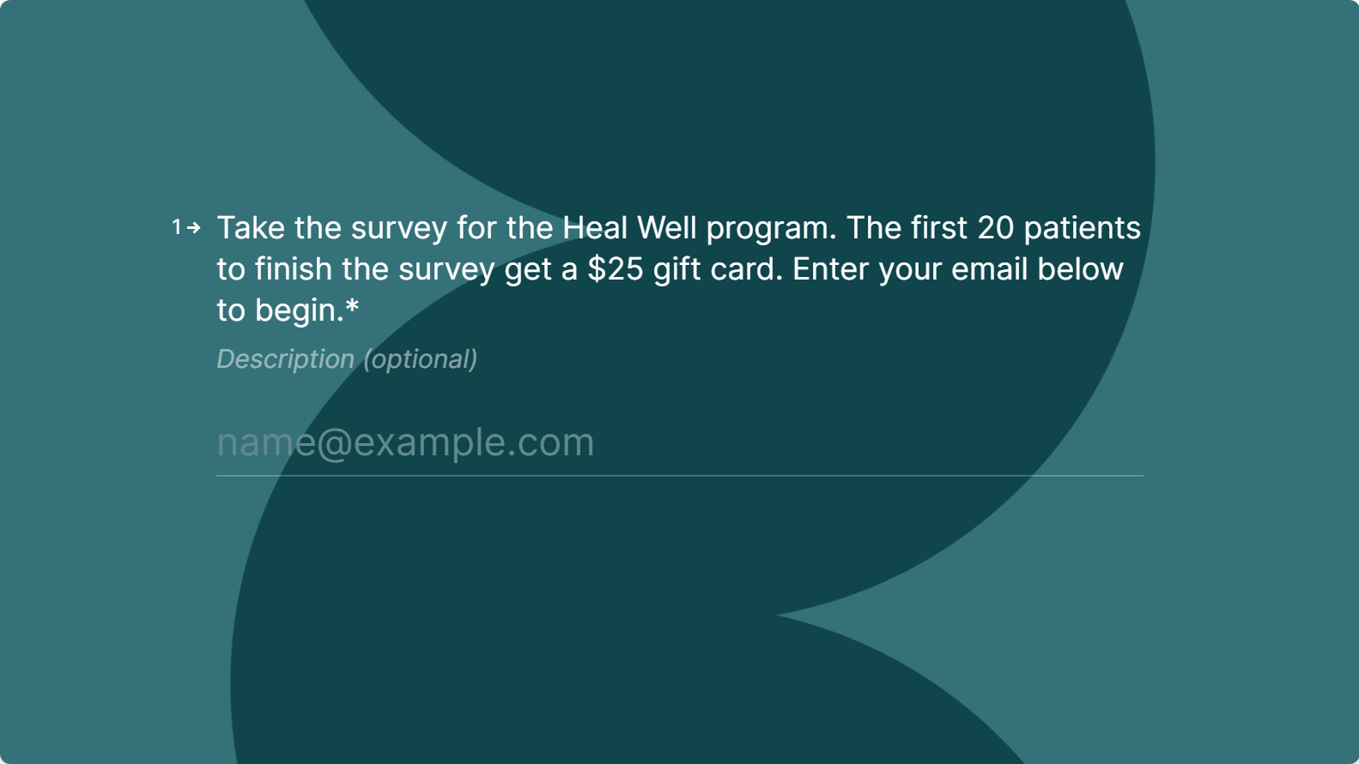

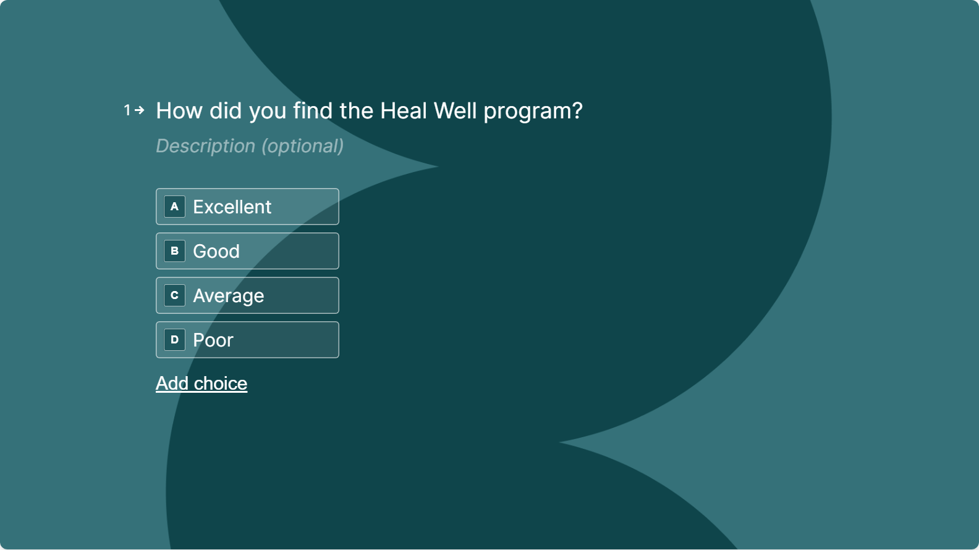

### 3.6 Updated Storyboard



 